DS001A Driver Monitoring Camera
User Guide and Technical Specifications
The DS001A is an in-cab camera with a built-in driver monitoring algorithm. It monitors driver fatigue and driving behaviour, provides voice alerts through a connected speaker, and outputs alarm signals for integration with a vehicle recorder or other equipment.
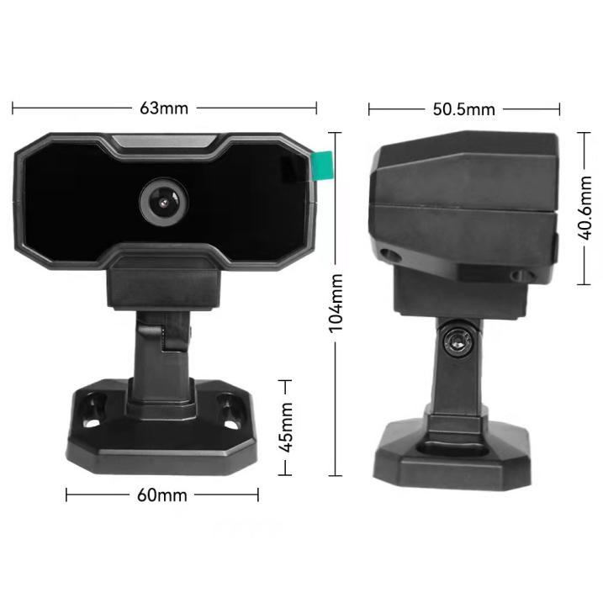
Camera dimensions 63 × 50.5 × 104 mm

1 Driver monitoring functions
Function | Detection
Driver fatigue | Detects signs of fatigue, including eye closure.
Seat belt unfastened | Detects when the driver is not wearing a seat belt.
Drinking water | Detects the driver drinking water.
Smoking | Detects the driver smoking.
Driver distraction | Detects inattentive driving.
Phone calls | Detects the driver making or receiving a phone call.
Abnormal posture | Provides an alert when abnormal driver posture is detected.
When an event is detected, the camera provides a voice alert, a 5 V high-level I/O alarm signal and an alarm message through the serial interface.

2 System connections
The standard system component is the DS001A driver monitoring camera. The cable assembly provides the following six connections.
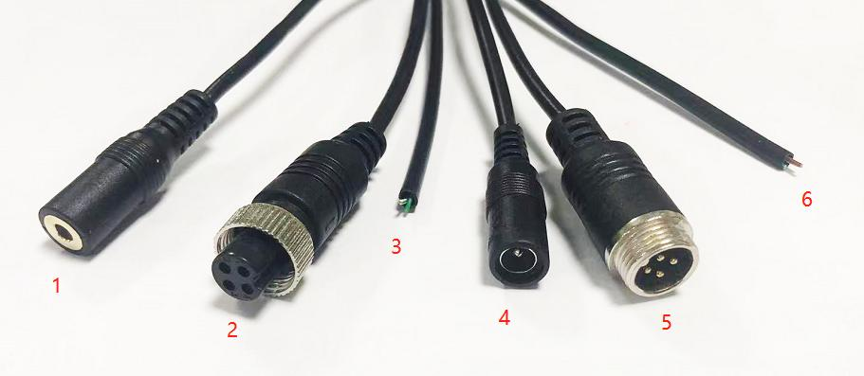
Cable assembly and connector numbers
No. | Connection | Purpose
1 | Speaker interface | Connects to an in-cab speaker for voice alerts.
2 | Video connector | Provides camera power, alarm audio output and AHD 720P video output.
3 | RS485 serial wires | Outputs alarm messages for integration with a vehicle recorder or multiple BSD cameras.
4 | DC power connector | DC 12-36 V power connection for the external audible and visual alarm.
5 | Audible and visual alarm connector | Provides power and a control signal for an external audible and visual alarm.
6 | GPS module interface | Connects an external GPS module; GPS speed can be used to filter alarms.

Alarm outputs
The camera supports one 5 V I/O alarm output and RS485 alarm data output. The video connector also carries alarm audio. Voice prompts are delivered through a connected in-cab speaker.

3 Interface definitions

3.1 Speaker interface
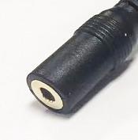
Connect an in-cab speaker to connector 1 for voice alerts to the driver.

3.2 Video connector
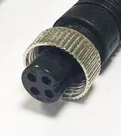
Pin | Signal | Description
1 | Power positive | 12 V
2 | Power negative | Ground
3 | Audio output | Alarm audio output
4 | Video output | AHD 720P signal output

3.3 RS485 serial interface
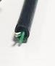
Wire | Signal
Green | RS485 A
White/green | RS485 B
Serial protocol output supports connection to a vehicle recorder or multiple BSD cameras. Refer to the camera communication protocol for integration details.

3.4 DC power connector
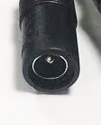
Connector 4 provides the DC 12-36 V power connection for the external audible and visual alarm.

3.5 Audible and visual alarm connector
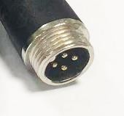
Pin | Signal | Description
1 | Power positive | 12-36 V
2 | Power negative | Ground
3 | Not connected | Unused
4 | Alarm output | Controls the external audible and visual alarm

3.6 GPS module interface

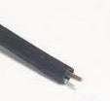
Connector 6 is for an external GPS positioning module. Vehicle speed from GPS can be used to filter alarm events.
Camera power supply: DC 12 V ±10%. The 12-36 V rating above applies to the external alarm connections.

4 Technical specifications
Parameter | Specification
Model | DS001A
CPU | ARM Cortex-A7
NPU | 0.6 TOPS
Image sensor | 1/3-inch CMOS, AHD 720P
Frame rate | 30 fps
Video standard | PAL
Effective resolution | 1080 (H) × 720 (V)
Effective pixels | 1.0 megapixel
Vertical sync frequency | 50 Hz / 60 Hz
Minimum illumination | Colour: 0.05 lux at F1.2
Video output level | 1.0 Vp-p, 75 Ω
Automatic gain control | Auto
Signal-to-noise ratio | >50 dB
White balance | Auto
Backlight compensation | Auto
Lens | 2.8 mm, F2.0
Field of view | 100°
Night vision | Starlight night vision
Audio | None
Built-in algorithm | Driver fatigue monitoring (DSM) algorithm
Alarm interface | 1 I/O alarm output, 5 V
Serial interface | RS485
Video interface | AHD signal
GPS interface | External GPS positioning module
Speaker interface | In-cab speaker interface for voice alerts
Current | 200 mA ±10%
Camera power supply | DC 12 V ±10%
Water protection | Not waterproof
Operating conditions | -40°C to +70°C; 95% RH maximum
Storage conditions | -30°C to +80°C; 95% RH maximum
Dimensions | 63 × 50.5 × 104 mm

5 Reference information

Purpose and scope
This document describes the DS001A camera for monitoring driver fatigue and driving behaviour in vehicles. It covers system functions, interfaces and technical specifications for use during system design, development, integration and testing.
DSM refers to the driver fatigue monitoring system in this document.

Reference document
Driver Fatigue Monitoring System Functional Specification.

Design and test standards
The following references apply to both design and testing.
Reference | Title | Edition
JT/T 883 | Technical requirements and test methods for driving hazard warning systems on commercial vehicles | 2014
GB/T 2423.1 | Environmental testing for electrical and electronic products - Test A: Cold | 2008
GB/T 2423.2 | Environmental testing for electrical and electronic products - Test B: Dry heat | 2008
GB/T 2423.5 | Environmental testing for electrical and electronic products - Test Ea and guidance: Shock | 2008
GB/T 2423.17 | Environmental testing for electrical and electronic products - Test Ka: Salt mist | 2008
GB/T 2423.56 | Environmental testing for electrical and electronic products - Test Fh: Broadband random vibration | 2008
GB/T 19951 | Road vehicles - Test methods for electrical disturbances from electrostatic discharge | 2008

Communication protocol
Refer to the DSM Camera Communication Protocol document for serial communication and alarm message definitions.

